Research Analysis

Joe Lanzi

June 21,2019

I.                Introduction

The purpose of this report is to conduct data analysis from a neuromorphic camera, iniVation Davis240, using machine learning, wavelength analysis, and pattern analysis.

II.              Theory

By using multiple techniques, create a pattern analyzation of data recorded from the neuromorphic camera.

III.            Data Preparation

The data recorded by the DVS240 neuromorphic camera is stored as a .AEDAT file which is then converted into a CVS file. The data consist of pixel polarity events, X and Y coordinate location of events in a 128 x 128-pixel block, and timestamp of events.

Once the data is converted into a CVS file, I was able to import this data into Python and store it using Series and Dataframe for optimized import. Extracting the data into multiple list took significantly longer. Taking only 2 seconds vs 60 to 120 seconds to import 1 million events.

After importing data, I had to normalize the timestamp so that the data recording begins at 0 microsecond.

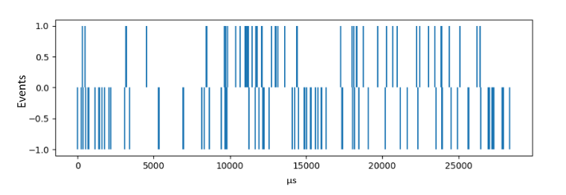Figure 1 – Visual plot of data using Python Matplotlib

IV.            Test

I collected multiple data on a 5/7 slot Wheel Chopping in different settings:

1. 3x DC Speed 25 HZ
2. 3x DC Speed 30 HZ
3. 3x DC Speed 35 HZ

With these data, I was able to compare two recordings with the same speed to each other to establish a proper algorithm for comparison.

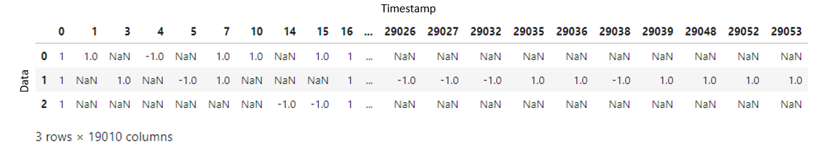

Figure 2 – 3x DC Speed 35 HZ in Python Dataframe

Without being able to compare the other data in the right timestamp, accounting for noise, and other multiple source of error, I created an algorithm to negated possible errors that compared Data 0 to every microsecond of Data 1 or Data 2 to achieve the highest percentage of similarity.

The results are:

20% similarity in events and 90% similarity in empty timestamp.

Total of only 55% similarity in the data with the same settings.

This test result is inconclusive and must be improved.

V.            Test Conclusion

Since analyzation of individual events gave inaccurate and unpredictable results, test comparison of individual events is inconclusive.

V.            Further Testing

For further testing, I started implementing Density analyzation using machine learning. For ease, I started to analyze the data by splitting it up in polarity for binary classification.

By converting polarity events into density patterns, I will be able to create multiple parameters to use for machine learning algorithms